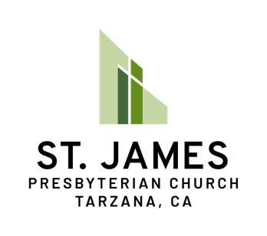
Memorial Service Pre-Planning Form

When a loved one passes away, the resulting tasks and responsibilities for surviving family members can quickly become overwhelming. It can be an incredible gift then to alleviate some of those responsibilities through pre-planning. At St. James Presbyterian, we want to celebrate and remember the lives of every member through memorial services, which give hope for the promise of resurrection. We encourage all our members to fill out this form, either on their own or alongside family members, so that we all can best celebrate your life! (Feel free to write answers on this sheet, on another piece of paper, or in a Word document)

Name:

What kind of Memorial Service would you like? Options include Sanctuary service, graveside service (usually restricted to fewer people), or both?

What scripture passage(s) would you like to have read and preached on?

What hymns or praise songs would you like to have sung or played?

Would you like there to be any other special music presentations? This could include non-sacred music during the prelude or postlude.

Services usually include 2-4 friends and family members who give a short eulogy. Are there any people you would like to speak at the service?

What kind of reception should be held after the service? Fellowship Hall can accommodate large groups and moderate sized meals. Or maybe there’s a special restaurant everyone could go to?

Are there any other special or specific elements you’d like to have incorporated in the service or reception?

There are normally several costs associated with memorial services (although these can be warmly negotiated), usually around $500. How would you like this to be funded?

Who should oversee planning the service with the Pastor? What is their contact info?

Do you currently donate to the church? If you have a monthly pledge, would you like it to be carried out for the remainder of the year after your passing? (Please contact the Church Office to find out this find out the current pledge amount)

Are there any other special gifts or donations that you would like to give to the church?

Thank you so much for filling out this form. It is truly a gift to your loved ones.

We encourage you to make two copies of this form (copies can be made at the church office, if needed). Please put one with your will and return one to the church office by dropping it off or (e-)mailing it to:

St. James Presbyterian Church
19414 Ventura Blvd
Tarzana, CA 91356

or jan@stjamespres.org

